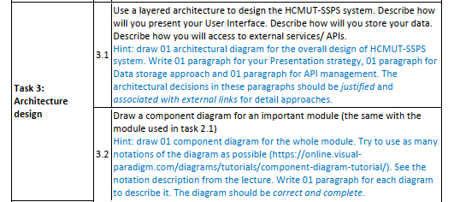

III. **Architecture Design**

**1. MVC Architecture**

The team has chosen the MVC (Model - View - Controller) architecture, one of the most popular architectures, to design the HCMUT_SPSS system.

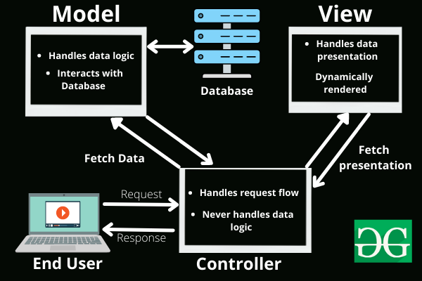

*Figure ..: MVC Architectural Model (Source: GeeksforGeeks.org)*

**1.1. Advantages and Disadvantages of MVC**

**Advantages of MVC:**

* **Separation of Concerns:** The MVC model separates the application into Model, View, and Controller, clarifying the responsibilities of each component, making code management and maintenance easier.
* **Easy Maintenance and Scalability:** The separation allows for easy modification or improvement of a part of the application without affecting the entire system.
* **Concurrent Development:** MVC enables multiple developers to work simultaneously on different parts of the application without causing code conflicts.
* **Easy Integration:** Components of the application can be changed or replaced without impacting other parts, facilitating the integration of new features.
* **Ease of Testing:** MVC supports testing individual components (Model, View, Controller) without the need to run the entire application.
* **Code Reusability:** Components in MVC can be reused in other projects, increasing development efficiency.

**Disadvantages of MVC:**

* **Increased Complexity:** MVC can increase the complexity in managing and communicating between Model, View, and Controller components.
* **Difficult to Manage in Complex Applications:** As the application grows, the number of Model, View, and Controller files increases, making code management and maintenance challenging without a proper organizational structure.

**1.2. Reasons for Choosing MVC over Layered Architecture**

After researching and analyzing the advantages and disadvantages of MVC architecture, the team decided to choose it because:

* **Easy Task Allocation:** Since MVC separates components, assigning tasks among team members becomes easier. Each member can focus on a specific part (Model, View, or Controller) without affecting others' work.
* **Concurrent Development:** MVC is more suitable than layered architecture for projects with multiple members. In layered architecture, each layer is a specific functional block; upper layers use services of the lower layers, making simultaneous testing among members difficult.
* **Supported by Many Frameworks and Libraries:** MVC is widely supported by many frameworks and libraries, making application development easier and more efficient compared to layered architecture.
* **Suitable for Project Scale:** SPSS is a medium-sized system, and MVC helps reduce difficulties in application management.
* **Learning and Application Opportunity:** MVC is a popular and widely applied model. Using this model is an opportunity for the team to learn and apply it effectively in the future.
* **Scalability and Flexibility:** MVC allows the application to be easily expanded and adapted to changing requirements.

**2 Architectural diagram and Deployment diagram**

**2.1.**

